Domino Fraction Activity
Materials needed (per pair)
- Dominos
- Whiteboard marker and whiteboards
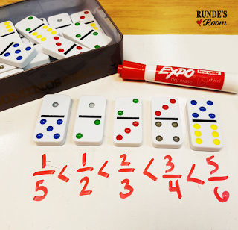
Stage 1 : Simply pick some random dominos from the tin and arrange in order from least to greatest for comparing fractions and finding common denominators.

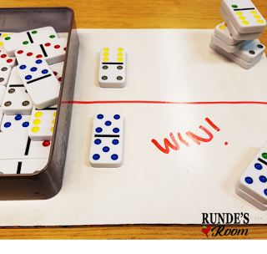

Stage 2: work with a partner (or the teacher) and play Fraction Domino War. Each person places a domino on their side of the whiteboard, and the student with the greatest fraction wins both dominos. The student with the most dominos at the end wins.

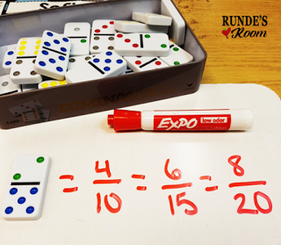
Stage 3: Pull a random domino from the tin and make equivalent fractions.

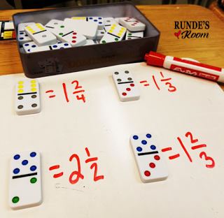
Stage 4: place the domino so that the higher number is on top (the numerator) and make mixed numbers from the improper fractions.

